Rising Waters: AI-Powered Flood Prediction
Description:
Rising Waters is an AI-powered flood prediction system that leverages Machine Learning to predict flood risks based on environmental and weather-related parameters. The platform provides users with a fast, reliable, and data-driven prediction experience to support disaster preparedness and early decision-making.
The system includes a Flood Prediction Module, which analyzes input parameters such as annual rainfall, monsoon rainfall, river water level, cloud cover, humidity, and temperature to determine the likelihood of flooding. A Data Processing Module cleans and preprocesses the input data before passing it to the trained Machine Learning model, ensuring accurate predictions. The Prediction Result Module instantly displays whether the selected area has a high or low flood risk, enabling users to take appropriate preventive measures.
Built using Python, Flask, HTML, CSS, and JavaScript, the system uses Scikit-learn Machine Learning models trained on historical flood datasets. The application offers a simple, user-friendly web interface and follows secure coding practices with proper input validation. Rising Waters helps government agencies, disaster management authorities, researchers, and the general public make informed decisions to reduce flood-related risks and improve community safety.

Scenarios
Scenario 1
A disaster management officer enters weather parameters such as annual rainfall, monsoon rainfall, river water level, humidity, and cloud cover into the system. The application analyzes the data and predicts a High Flood Risk, enabling authorities to issue early warnings and prepare emergency response measures.
Scenario 2
A local government official uses the application to assess flood risk before the monsoon season. The system predicts a Low Flood Risk based on the provided environmental data, helping officials allocate resources efficiently while continuing routine monitoring.
Scenario 3
A researcher tests different environmental conditions by entering historical weather values into the application. The Machine Learning model generates flood risk predictions, allowing the researcher to analyze patterns, compare results, and evaluate the impact of different weather conditions on flood occurrence.

Technical Architecture:
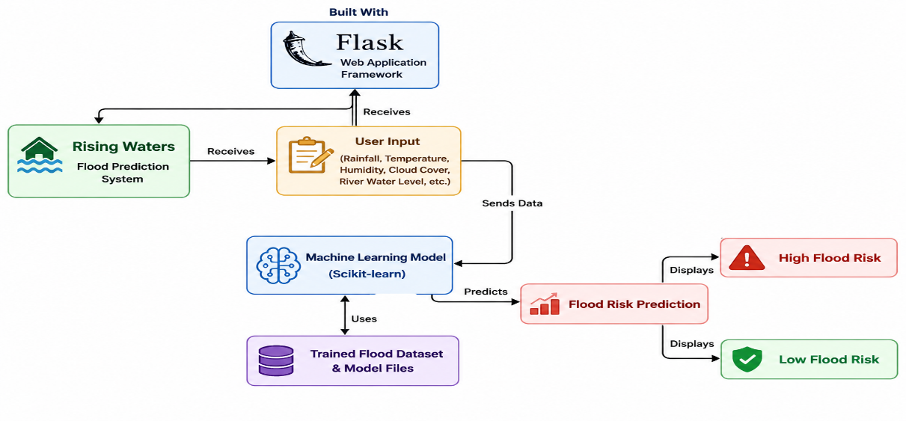
Description
Rising Waters utilizes a modular three-tier architecture to provide accurate and efficient flood risk prediction using Machine Learning. The frontend offers a responsive web interface developed with HTML, CSS, and JavaScript, allowing users to enter weather and environmental parameters. The Flask-based backend validates user inputs, preprocesses the data, and passes it to a trained Scikit-learn Machine Learning model for prediction. The application then displays the predicted flood risk (High or Low) through an easy-to-use interface. The system is designed for local deployment and can be hosted on cloud platforms such as Render or IBM Cloud for public access.

(Note: If you are using database in your project definitely you need to add ER Diagram along with description)

Pre-requisites:
- Flask Framework Knowledge: Flask Documentation
- Python Programming: Python Documentation
- Machine Learning with Scikit-learn: Scikit-learn Documentation
- Data Analysis using Pandas & NumPy: Pandas and NumPy Documentation
- HTML, CSS, and JavaScript Skills: W3Schools HTML/CSS/JavaScript Tutorials
- Version Control with Git & GitHub: Git Documentation
- Development Environment: Visual Studio Code / Jupyter Notebook
- Cloud Deployment (Optional): Render or IBM Cloud Documentation

Project Workflow:
Milestone 1: Data Collection, Model Selection & Architecture
- Activity 1.1: Collect and preprocess historical flood and weather datasets for model training.
- Activity 1.2: Research, compare, and select the most suitable Machine Learning algorithm (Decision Tree, Random Forest, KNN, etc.) for flood prediction.
- Activity 1.3: Design the system architecture, defining interactions between the user interface, Flask backend, Machine Learning model, and prediction module.
- Activity 1.4: Set up the development environment by installing Python, Flask, Scikit-learn, Pandas, NumPy, Matplotlib, and other required libraries.

Milestone 2: Core Functionalities Development
- Activity 2.1: Develop the data preprocessing and feature engineering modules for flood prediction.
- Activity 2.2: Train, test, and evaluate the Machine Learning model using historical flood data.
- Activity 2.3: Implement the prediction module to classify flood risk as High or Low.

Milestone 3: Flask Application Development
- Activity 3.1: Develop the main application (app.py) with Flask routing and Machine Learning model integration.
- Activity 3.2: Implement user input validation and display flood prediction results through the web application.

Milestone 4: Frontend Development
- Activity 4.1: Design and develop a responsive user interface using HTML, CSS, and JavaScript.
- Activity 4.2: Create dynamic Flask templates to collect environmental parameters and display prediction results.

Milestone 5: Testing & Deployment
- Activity 5.1: Perform functional testing and validate prediction accuracy using test datasets.
- Activity 5.2: Prepare the application for deployment by configuring dependencies and generating the requirements.txt file.
- Activity 5.3: Deploy the Flask application on a hosting platform such as Render or IBM Cloud (or run locally for demonstration).

Milestone 6: Conclusion
- Activity 6.1: Evaluate the overall performance and accuracy of the flood prediction system.
- Activity 6.2: Document the project, prepare the final presentation, and identify future enhancements such as real-time weather API integration, SMS alerts, and cloud scalability.

Milestone 1: Model Selection and Architecture
In this milestone, the focus is on selecting the most suitable Machine Learning model for flood prediction based on historical weather and environmental data. The architecture of the application is designed to provide users with a simple web interface that collects environmental parameters, processes them using a trained Machine Learning model, and predicts the likelihood of flooding accurately and efficiently.
Activity 1.1: Collect and Prepare the Flood Dataset
Before training the Machine Learning model, a suitable dataset containing historical flood-related information must be collected and prepared.
- Step 1 – Collect Dataset: Download a flood prediction dataset from trusted sources such as Kaggle or government weather datasets.
- Step 2 – Analyze the Dataset: Examine the dataset features such as rainfall, temperature, humidity, river water level, cloud cover, soil moisture, and flood status.
- Step 3 – Data Cleaning: Remove missing values, duplicate records, and incorrect entries to improve data quality.
- Step 4 – Data Preprocessing: Encode categorical values (if any), normalize numerical features, and split the dataset into training and testing sets.
- Step 5 – Save the Processed Dataset: Store the cleaned dataset for model training and evaluation.
- Important: Keep the original dataset unchanged and use the processed dataset for training purposes.
Activity 1.2: Research and Select the Appropriate Machine Learning Model
The following tasks were performed to identify the best model for flood prediction.
- Understand the project requirements and identify the important environmental factors affecting floods.
- Study different Machine Learning algorithms such as Decision Tree, Random Forest, K-Nearest Neighbors (KNN), Logistic Regression, and XGBoost.
- Compare the models based on prediction accuracy, training time, and overall performance.
- Evaluate each model using standard metrics such as Accuracy, Precision, Recall, and F1-Score.
- Select the best-performing model for deployment. In this project, the Decision Tree Classifier was selected because it achieved high prediction accuracy while remaining simple, fast, and easy to interpret.
Activity 1.3: Define the Architecture of the Application
The application architecture consists of the following major components.
- Frontend: Develop a user-friendly web interface using HTML, CSS, and JavaScript where users enter environmental parameters.
- Backend: Implement the application using the Flask framework to receive user input, validate data, load the trained Machine Learning model, and process prediction requests.
- Machine Learning Module: Load the trained Decision Tree model using Joblib and generate flood predictions based on user inputs.
- Prediction Output: Display the prediction result indicating either High Flood Risk or Low Flood Risk along with the entered environmental values.
- Overall Workflow: User Input → Flask Backend → Machine Learning Model → Flood Prediction Result.
Activity 1.4: Set Up the Development Environment
The development environment was configured using the following steps.
- Install Python: Install Python 3.10 or later.
- Create a Virtual Environment:
python -m venv venv
- Activate the Virtual Environment:
venv\Scripts\activate
- Install Required Libraries:
pip install flask
pip install pandas
pip install numpy
pip install scikit-learn
pip install matplotlib
pip install seaborn
pip install joblib
Or install all dependencies together using:
pip install -r requirements.txt
- Create Project Structure: Organize the project into folders such as:
Rising-Waters/
├── app.py
├── requirements.txt
├── model.pkl
├── dataset/
├── notebooks/
├── templates/
├── static/
├── README.md
└── .gitignore
- Run the Flask Application:
python app.py
- Open the Application: Access the project through:
http://127.0.0.1:5000/

Milestone 2: Core Functionalities Development
Activity 2.1: Develop Core Flood Prediction Features
Develop the primary functionalities of the Rising Waters application to accurately predict flood risk using Machine Learning.
Flood Risk Prediction
- Accept environmental parameters such as annual rainfall, temperature, humidity, cloud cover, river water level, soil moisture, and seasonal rainfall from the user.
- Process the input data and generate a flood prediction using the trained Machine Learning model.
- Display the prediction result as High Flood Risk or Low Flood Risk with a user-friendly interface.
Input Validation
- Validate all user inputs before processing.
- Ensure that only valid numerical values within acceptable ranges are accepted.
- Display appropriate error messages for missing or invalid inputs.
Prediction Result Display
- Present the flood prediction result instantly after processing.
- Display the predicted flood risk clearly so users can understand the outcome easily.
- Provide a clean and responsive interface for better user experience.

Activity 2.2: Implement the Flask Backend
Define Routes in Flask
- Create the main routes in app.py for loading the home page and handling flood prediction requests.
- Configure Flask to render the HTML templates and return prediction results.
Process User Input
- Design an input form in index.html where users enter environmental parameters such as rainfall, humidity, temperature, cloud cover, and river water level.
- Use Flask's request.form method to receive the submitted data from the web page.
- Validate all input values before sending them to the Machine Learning model for prediction.
Load and Execute the Machine Learning Model
- Load the trained Machine Learning model using the Joblib library during application startup.
- Convert user input into the required numerical format expected by the model.
- Pass the processed input to the trained Decision Tree model for flood prediction.
Generate Prediction
- Receive the prediction from the Machine Learning model.
- Determine whether the area has a High Flood Risk or Low Flood Risk based on the model output.
- Display the prediction result on the web page along with the entered environmental parameters.
Error Handling
- Handle invalid inputs and unexpected application errors gracefully.
- Display meaningful messages to users if prediction cannot be completed.
- Ensure the application continues running without crashing during incorrect input or runtime exceptions.

Milestone 3: App.py Development
Milestone 3 focuses on developing the core logic of the app.py file, which acts as the backbone of the Rising Waters Flood Prediction System. In this milestone, the Flask application is configured to receive user inputs, process environmental data, invoke the trained Machine Learning model, and display flood prediction results. The application is also tested to ensure reliable and accurate predictions.

Activity 3.1: Writing the Main Application Logic in app.py
Define the Core Routes in app.py
Establish the main routes for the Rising Waters application.
Home Route (/)
- Displays the main web interface where users can enter flood-related environmental parameters.
- Loads the index.html page using Flask's render_template() function.
@app.route("/")
def home():
return render_template("index.html")

Prediction Route (/predict)
- Accepts user input from the web form.
- Reads environmental parameters such as rainfall, humidity, temperature, cloud cover, soil moisture, and river water level.
- Validates all user inputs.
- Sends the processed data to the trained Machine Learning model.
- Returns the prediction result to the user interface.
@app.route("/predict", methods=["POST"])
def predict():
rainfall = float(request.form["rainfall"])
temperature = float(request.form["temperature"])
humidity = float(request.form["humidity"])

prediction = model.predict([[rainfall, temperature, humidity]])

return render_template("index.html", prediction=prediction)

Set Up Route Handlers
Home Route
- Displays the Flood Prediction webpage.
- Allows users to enter environmental parameters.
Prediction Route
- Receives user inputs submitted from the HTML form.
- Performs input validation.
- Converts input values into numerical format.
- Passes the values to the trained Machine Learning model.
- Displays the prediction result as High Flood Risk or Low Flood Risk.

Load the Machine Learning Model
- Load the trained flood prediction model during application startup using the Joblib library.
- Store the model in memory to improve prediction speed.
import joblib

model = joblib.load("model.pkl")

Process User Inputs
- Receive input values from the HTML form using request.form.
- Convert all values into numerical format.
- Arrange the values according to the dataset feature order.
Example input parameters:
- Annual Rainfall
- Temperature
- Humidity
- Cloud Cover
- River Water Level
- Soil Moisture
- Seasonal Rainfall

Generate Flood Prediction
- Pass the processed data into the trained Decision Tree Machine Learning model.
- Receive the prediction result.
- Determine whether the flood risk is High or Low.
- Display the prediction result on the webpage.

Error Handling
- Check whether all required fields are entered.
- Handle invalid or missing numerical values.
- Prevent application crashes by displaying user-friendly error messages.
- Log unexpected exceptions for debugging.

Model Integration
- Integrate the trained Scikit-learn Decision Tree Model with the Flask application.
- Ensure the prediction model loads only once when the application starts.
- Reuse the loaded model for all prediction requests to improve efficiency.

Data Flow
The application processes user requests in the following order:
User → HTML Form → Flask (app.py) → Input Validation → Machine Learning Model → Flood Prediction → Display Result

Testing the Application
- Verify that all input fields accept valid environmental data.
- Test prediction accuracy using sample dataset values.
- Validate correct display of High Flood Risk and Low Flood Risk predictions.
- Ensure the application responds without runtime errors.

This milestone successfully establishes the complete application logic for the Rising Waters Flood Prediction System, enabling users to enter environmental data, process it through a trained Machine Learning model, and receive accurate flood risk predictions through a simple and interactive web interface.

Milestone 4: Frontend Development
Milestone 4 focuses on developing a user-friendly and responsive web interface for the Rising Waters Flood Prediction System. The frontend is designed using HTML, CSS, and JavaScript to provide an intuitive platform where users can easily enter environmental parameters and instantly view flood prediction results. The interface emphasizes simplicity, accessibility, and responsiveness across multiple devices.

Activity 4.1: Designing and Developing the User Interface
Set Up the Base HTML Structure
- Develop the main index.html page as the primary interface for the application.
- Include a project title, navigation header, flood prediction form, and prediction result section.
- Use semantic HTML elements to organize the webpage and improve accessibility.
- Design a clean and responsive layout that allows users to enter environmental parameters easily.

Design a Responsive Layout Using CSS
- Create a stylesheet (static/css/style.css) to provide an attractive and responsive user interface.
- Use modern CSS techniques such as Flexbox and Grid Layout to arrange page components neatly.
- Apply consistent colors, typography, spacing, and buttons to improve user experience.
- Implement responsive media queries so the application works smoothly on desktop, tablet, and mobile devices.

Create Separate User Interface Components
- Input Form: A form containing fields for rainfall, temperature, humidity, cloud cover, river water level, soil moisture, and seasonal rainfall.
- Prediction Button: A button that submits the entered values for flood prediction.
- Prediction Result Card: Displays the prediction result as High Flood Risk or Low Flood Risk with a clear and user-friendly design.
- Navigation/Header: Displays the project title and provides a professional appearance.

Activity 4.2: Creating Dynamic Content Rendering with JavaScript
Handle Form Submission
- Capture user input using JavaScript and submit the prediction request to the Flask backend.
- Validate all required fields before sending the data.
- Prevent invalid or empty values from being submitted.

Display Prediction Results Dynamically
- Receive the prediction response from the Flask backend.
- Display the flood prediction result without requiring users to reload the page (if JavaScript is used).
- Clearly indicate whether the predicted flood risk is High or Low.

Improve User Experience
- Display a loading indicator while the prediction is being processed.
- Show meaningful error messages if invalid input is provided.
- Automatically update the prediction section after receiving the result.

Responsive User Interface
- Ensure that all form elements resize automatically for different screen sizes.
- Optimize the interface for desktops, laptops, tablets, and smartphones.
- Maintain a consistent and easy-to-use design across all devices.

Frontend Technologies Used
- HTML5 – Structure of the web pages.
- CSS3 – Styling and responsive design.
- JavaScript – Client-side validation and dynamic interactions.
- Flask Templates (Jinja2) – Dynamic rendering of prediction results.
- Bootstrap (Optional) – Responsive layout components (if used in your project).
Milestone 5: Deployment
In Milestone 5, the focus is on deploying the Rising Waters Flood Prediction System. The application is first tested locally to ensure that all functionalities work correctly. After successful local testing, the application can be deployed on a cloud platform such as Render or IBM Cloud to make it accessible through a public URL. This process includes configuring the environment, installing dependencies, and verifying the deployed application.

Activity 5.1: Preparing the Application for Local Deployment
Set Up a Virtual Environment
- Open Command Prompt or Visual Studio Code Terminal.
- Navigate to the project directory.
- Create a virtual environment and activate it.
python -m venv venv
venv\Scripts\activate
- Install all required project dependencies.
pip install -r requirements.txt

Configure the Project Environment
- Ensure all required files are available.
app.py
model.pkl
requirements.txt
templates/
static/
dataset/
- Verify that the trained Machine Learning model (model.pkl) is located in the project directory.
- Ensure Python and Flask are installed correctly.

Activity 5.2: Local Testing and Verification
Start the Flask Development Server
Run the application locally using:
python app.py
The Flask server starts successfully.
Open any web browser and navigate to:
http://127.0.0.1:5000/

Verify Application Functionality
Perform the following tests:
- Enter rainfall, humidity, temperature, cloud cover, river water level, and other environmental values.
- Click the Predict button.
- Verify that the application correctly predicts either High Flood Risk or Low Flood Risk.
- Test multiple input combinations using sample dataset values.
- Confirm that all pages load correctly without errors.

Activity 5.3: Public Deployment
After successful local testing, prepare the application for public deployment.
Generate Requirements File
Create the dependency file.
pip freeze > requirements.txt

Deploy the Application
Deploy the Flask application using a cloud hosting platform such as:
- Render
- IBM Cloud
- Railway (Optional)
Upload the project repository from GitHub and configure the deployment settings.

Deployment Configuration
Use the following commands during deployment.
Build Command
pip install -r requirements.txt
Start Command
python app.py
or (if using Gunicorn)
gunicorn app:app

Verify Public Deployment
After deployment:
- Open the generated public URL.
- Test the application using different environmental parameters.
- Verify that predictions are displayed correctly.
- Ensure the website is accessible from different devices and browsers.

Important Notes
- Ensure that all required Python libraries are listed in requirements.txt.
- Keep the trained model.pkl file in the project directory before deployment.
- Test the application locally before deploying to avoid runtime errors.
- Free hosting platforms such as Render may temporarily put the application to sleep after periods of inactivity. The first request after inactivity may take a few seconds to respond.
- If deployment issues occur, verify that the Flask application starts correctly and all dependencies are installed.

Exploring the Website’s Web Pages:
Home / Generator Page:
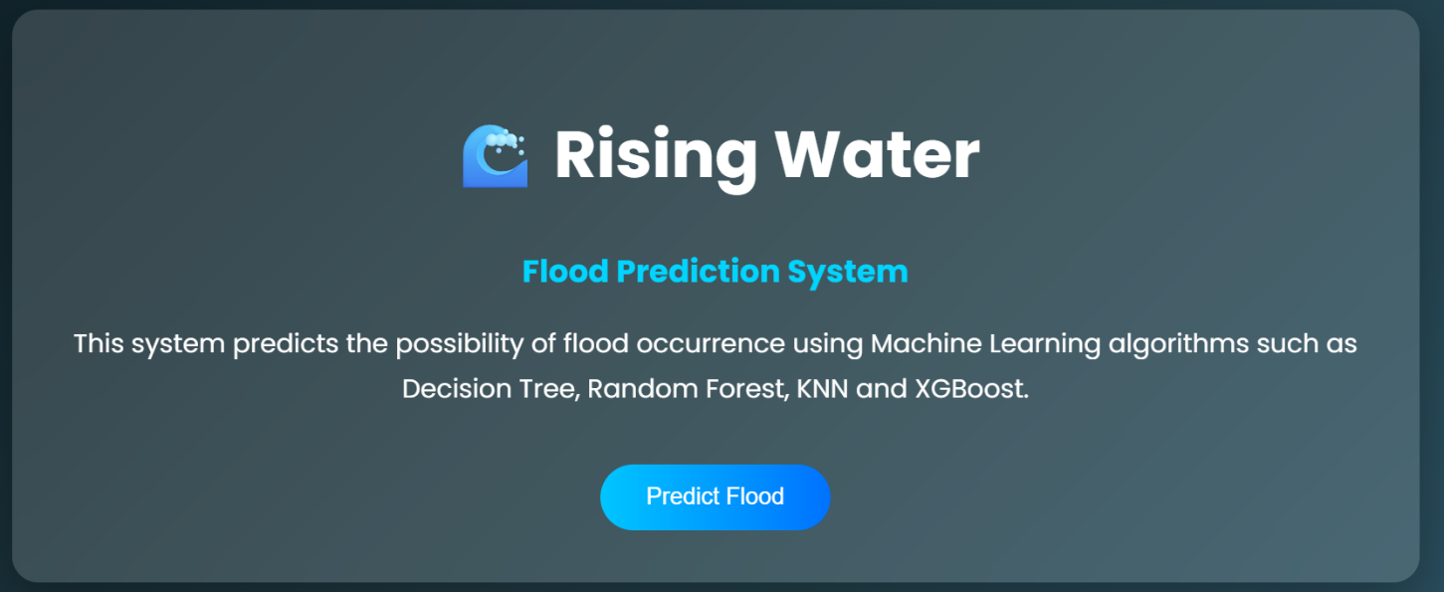

Description:
The Rising Waters web application serves as both the landing page and the flood prediction interface. It features a clean, responsive, and user-friendly design developed using HTML, CSS, JavaScript, and Flask. The homepage displays the project title, a brief description of the system, and a flood prediction form where users can enter environmental parameters. Once the required information is submitted, the application processes the data using the trained Machine Learning model and displays the predicted flood risk on the same page.

Input Section:
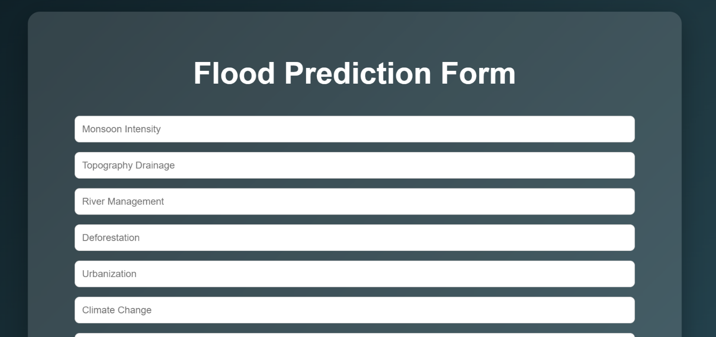

Description
The input section contains the main Flood Prediction Form. Users enter environmental parameters such as Annual Rainfall, Temperature, Humidity, Cloud Cover, River Water Level, Soil Moisture, and Seasonal Rainfall into the respective input fields. After entering all the required values, users click the Predict Flood Risk button. The application validates the input data, sends it to the Flask backend, and processes it using the trained Machine Learning model. The predicted result (High Flood Risk or Low Flood Risk) is then displayed instantly on the webpage, providing users with a simple and efficient flood risk assessment experience.
Results Section:
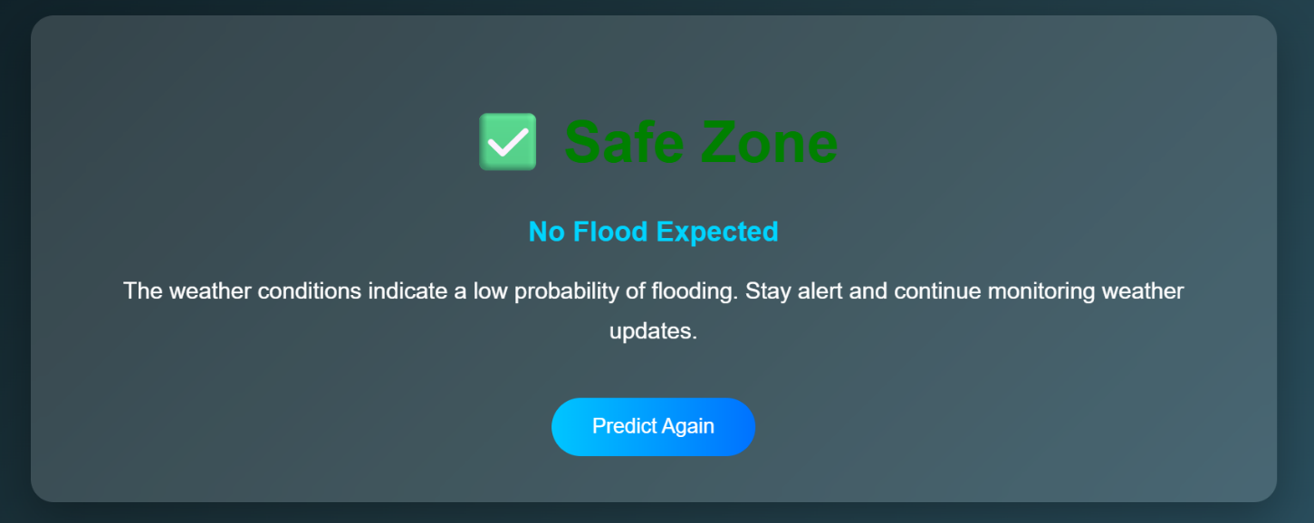

Description:
After the user submits the environmental parameters, the Prediction Result section is displayed on the same page. This section presents the flood prediction generated by the trained Machine Learning model. It clearly indicates whether the selected location has a High Flood Risk or Low Flood Risk. The page also displays the entered weather parameters for reference, allowing users to verify their inputs. The prediction result is presented in a clean and easy-to-read card layout, providing quick insights for disaster preparedness and decision-making. After prediction, the page automatically focuses on the result section, ensuring a smooth and user-friendly experience.
Conclusion:
Rising Waters is a Machine Learning-based flood prediction system developed using Flask, HTML, CSS, JavaScript, and Scikit-learn to provide early flood risk assessment based on environmental and weather-related parameters. The application enables users to enter values such as rainfall, temperature, humidity, cloud cover, river water level, and seasonal rainfall, and instantly predicts whether the flood risk is High or Low using a trained Decision Tree Machine Learning model. The project demonstrates how Machine Learning can improve disaster preparedness by providing quick, reliable, and user-friendly flood risk predictions through a simple web application.
Looking ahead, Rising Waters has significant potential for future enhancements. The system can be integrated with real-time weather APIs to provide live flood predictions, GIS mapping to visualize flood-prone areas, and SMS/Email alert services to notify users during high-risk situations. Additional improvements such as cloud deployment, mobile application support, IoT sensor integration, and advanced Deep Learning models can further increase prediction accuracy, scalability, and accessibility, making the platform a valuable tool for disaster management agencies, local authorities, and the general public.

